WHAT IS ADVOCACY?

You have rights at any age and it’s important you know what they are.

Did you know you have the right to speak up for yourself when adults are making decisions for you?

Advocacy will support you and make sure that your voice is heard when decisions affecting you are being made.

ABOUT ME
ADVOCACY SUPPORT

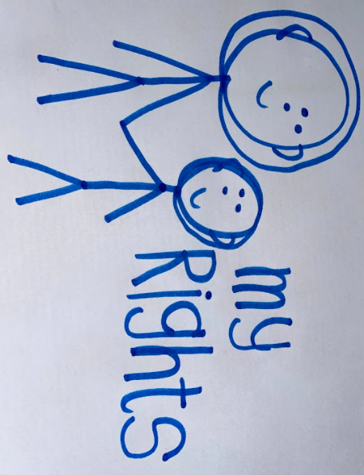




Lesley Tucker ALNCo
01633 484320
Lesley.tucker@gmp.schoolsedu.org.uk

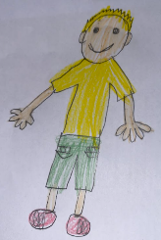

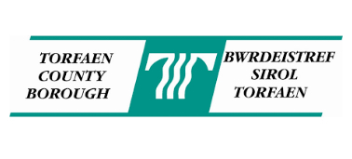

SO, WHAT WILL AN ADVOCATE DO?
Help you speak up for yourself or speak on your behalf if that’s what you want.
Listen to your concerns or worries and help you to act on them.
Be open and honest with you. Help you challenge decisions. Help you prepare for meetings. Explain to adults how you are feeling.
Explain to you what is happening and what is planned to happen.
Help you to sort out a problem if you are thinking of making a complaint, a claim of discrimination or an appeal

An advocate will not: judge you
tell you what to do
talk to anyone else without your permission-unless you’ve told them that they can!

SNAP CYMRU
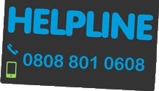www.snapcymru.org/information-for-young-people

NYAS
www.nyas.net OR
http://youngpeople.nyas.net/index.php/get- in-touch/nyas-helpline

The Helpline is open 9 am until 6 pm Monday to Friday excluding Bank Holidays. You can contact them by:
Freephone helpline – 0808 808 1001 – please note that some mobile networks may charge the same as a landline charge to connect to 0808 numbers.

EMAIL – help@nyas.net

In writing – write ‘FREEPOST NYAS’ on the envelope that contains your letter to us.

Call Back – we will call you
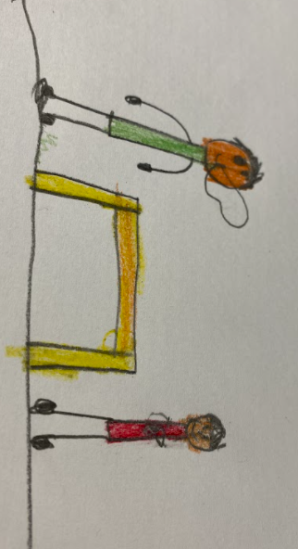
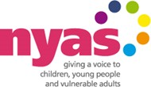

HOW TO GET SUPPORT?
You can speak to your family, school, youth worker or social worker about getting an advocate.

You can also contact SNAP Cymru directly and speak to a Family and Young Persons Officer.

